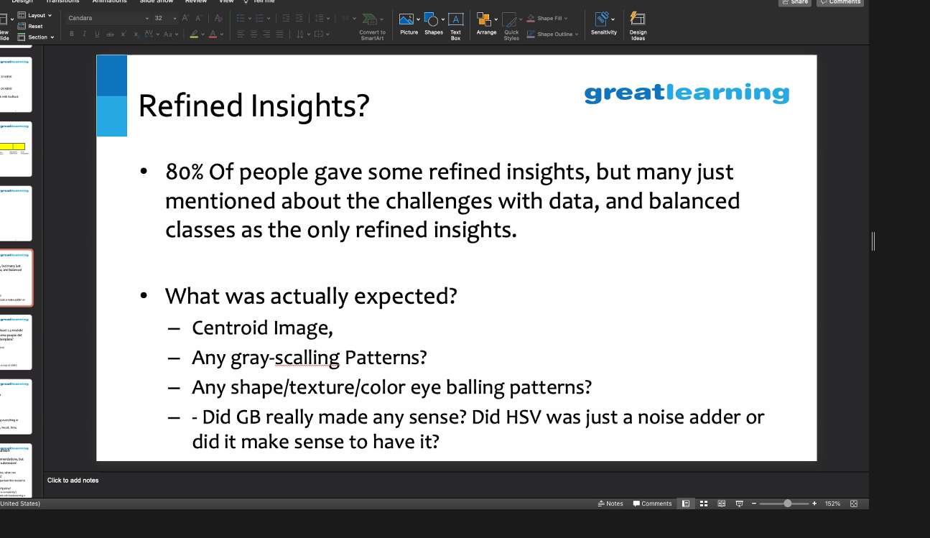

Hyperparameter tuning

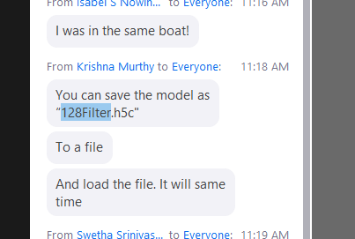

model.load(“28filter-94p-custom.h5”

Use a threshold of .25 probability with binary cross entropy

Spoiler alert: VGG16 with raw images, does it in 2 minutes too. Saves lot of time

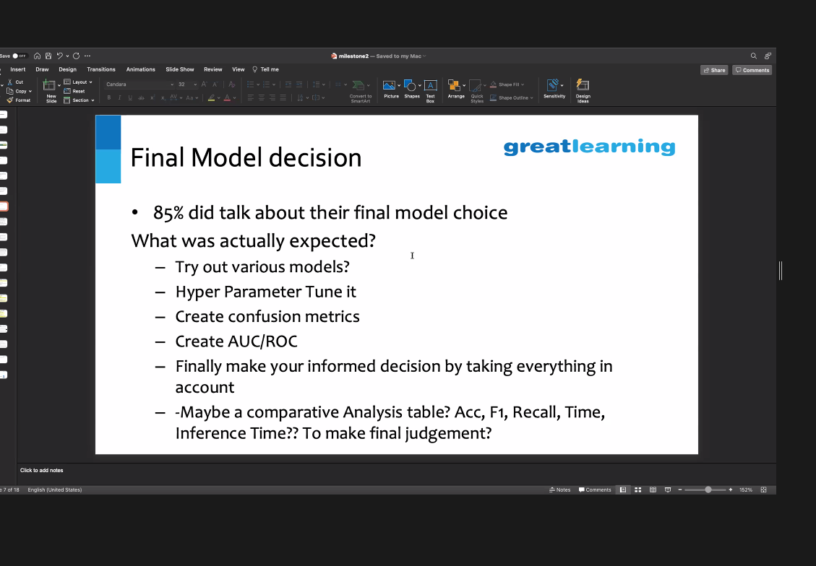

@Gajendra, is it possible that you demonstrate your solution on Slack later? you've made me curious to know :)

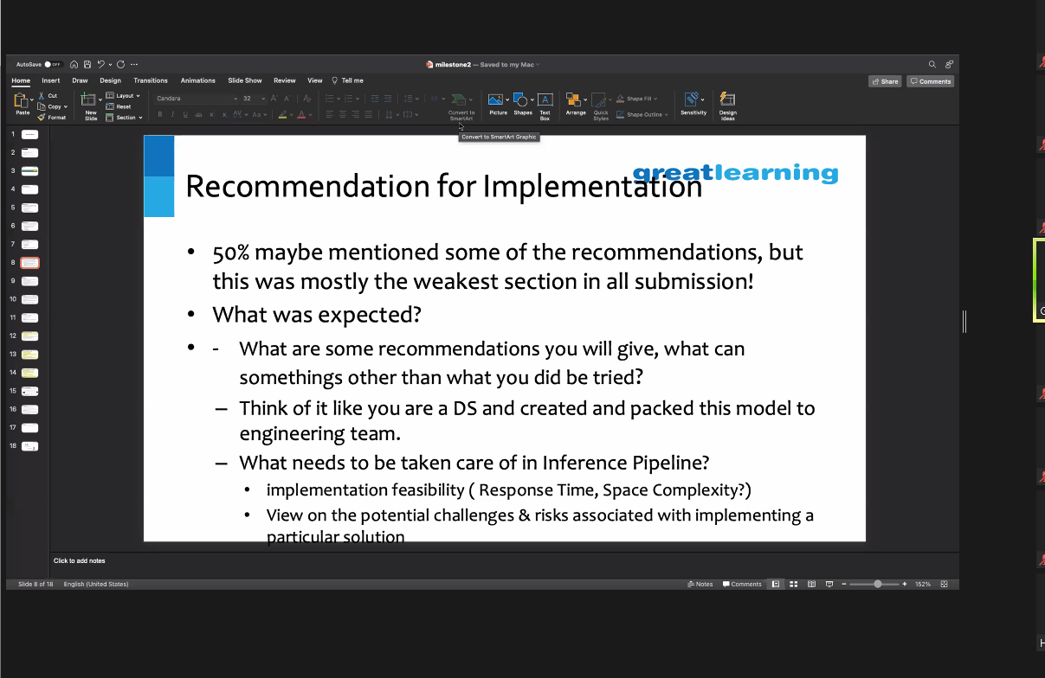

KRAS trainer hyper parameter training.

Change optimizer

Cross validation

Evaluation : Show the problematic in the recale or wrongly predicted images with Confusion matrix

ROC AUC: using for module evaluation + Confusion matrix

Using pickle to binarize and pkl file

Set random seeds

Build a dictionary for the different testings

What is softmax numbers?